INEX - India International & Invention Expo
INEX 2022

A full-length paper on
Title: To Create an AI Camera for Real-Time Security:
NEXT GEN CAMERA

Akshit Kumar Lall (Age:15 years)
IYIIC - CUB Category
Delhi Public School Patna, Bihar
Vill. Chandmari, P.S, Shahpur- Hathiyakandh Sarai Rd, Danapur Cantonment,
Patna, Bihar 801502
E-mail: akshit6830@gmail.com

ABSTRACT
- Next Gen Camera is the Integration of Artificial Intelligence and Camera for solving daily life problems. It mainly focuses on Security issues by using already built CCTV Cameras. Using Next Gen Camera we can detect Fire, Robbers, Weapons, and many other things using the already built infrastructure.
- It is also less costly than traditional methods and very efficient & effective. Features such as Fire Detection, Robber & Gun Detection, Faint Detection are done by using just a CCTV camera which is already available in most places, and by adding a box with the circuit, backup power supply, and a single-time estimated investment of around Rupee 500-1000 which can fit in the current system without many upgradations, therefore, making it Sustainable.
- Even people with low income can use these in their homes to make them secure from Fire, Robbers, any alone person fainting when you are out, and many more things. With the help of AI, cameras will be more intelligent and solve our real-life problems.
- Next Gen camera does not only show the video but also has its target to detect people or objects. When it detects its assigned target, the system will play a buzzer, thus alerting the people around and that leads to a real-time solution rather than simply recording the event.
- This project has been completely made from Python Programming language, normally there needs to be a person behind the cameras but in this case, this is completely automatic.
- In the future, we will have a Next Gen Camera to detect persons as well as many different objects to have better security to provide an increased standard of living.
Contents
INTRODUCTION 3
AIMS AND OBJECTIVES OF THE STUDY 8
HYPOTHESIS 9
NEED STATEMENT 10
WORK PLAN 11
METHODOLOGY 12
OBSERVATIONS 13
DATA ANALYSIS AND INTERPRETATION 20
RESULTS 21
IMPROVEMENT AFTER THE FEEDBACK FROM JUDGES: 22
CONCLUSION: 24
FUTURE PLAN: 25
ACKNOWLEDGMENT: 27
REFERENCES : 23
PYTHON PROGRAM 24

INTRODUCTION

A month ago, in Aashina Digha road, in an apartment, there was a robbery at noon. Even if there were CCTV cameras, they would not have been able to do much other than record the event.
Robbery has also been increased due to the pandemic where people have lost jobs. In my group member’s house, there was a fire accident and all his toys were burnt in spite of CCTV cameras. In 2019, out of the 11,037 Fire Accidents, a total of 6,364 accidents i.e., around 57% occurred in Residential Buildings^{[i]}.
About 2.4% of Accidental deaths were due to Fire Accidents ^{[ii]}. This made us think about developing a smart AI camera that can detect robbers, fires, and many other things and with a buzzer system to alert the concerned people instantly.
Nowadays Cameras are very common in different places like CCTV Cameras.
In hospitals, societies, offices, homes, etc. Artificial Intelligence (AI) has also grown a lot in recent years and by using Python Programming language we developed a smart AI camera called NEXT GEN CAMERA.

Features of Next Gen Camera:

- FIRE DETECTION :
The system works on neural networks which simply means that AI is trained with thousands of images of fire which will make it learn characteristics of fire, then it can recognize similar images of fire with its gained knowledge. This is how our brains also work. The whole system is made using the Python Programming Language. That means Next Gen Camera not only display and record the event but also detect the fire with buzzer sound that would make people aware and alert about the same. Also, at the same time an automatic message and a phone call will go to the concerned people.
Traditional Smoke detectors or fire alarms are
- expensive,
- use radioactive materials,
- have less life as compared to Next Gen Camera,
- need to be cleaned to detect smoke,
- Are very sensitive, therefore detecting cigarette smoke and incense sticks.
- cannot be fitted at every inch.
But by using Next Gen Camera clears out all these problems with efficiency and also reduces cost.
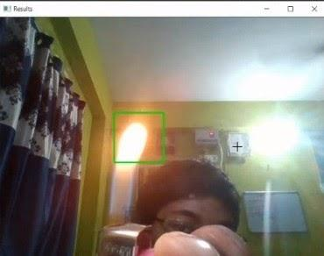

- ROBBER & WEAPON DETECTION:
Using Next Gen Camera, we can also detect robbers and weapons. It will be done in a similar way the fire detection was done that means the moment robber or gun etc. identified by the camera, buzzer sound will start as well as call and message will be sent to the concerned people.
- Guards cannot watch the cameras 24x7 and they are also expensive as they are paid on a monthly basis and cannot be afforded by middle-class families.
- They are also exposed to greater liability.
- They might be even hired by criminals.
- Even if a robber comes and gets robs the place, with simple CCTV camera footage, we can’t do much of it but with AI it will detect instantly and inform the nearby police and the surrounding areas by starting alarms.
- This way it saves energy by not involving human labor and saves cost.
Next Gen Camera eliminates almost all problems with Security Guards.

- Having the advantage of being an electronic device with very few moving parts. Maintenance is also not needed much as it can work as long as it is working. This increases its life and making it more effective.

- As far as the Hardware is concerned, it will come in the form of a box that has a custom designed circuit board built only for this purpose. It can handle multiple cameras. For societies or places where we have more cameras, we can get the upgraded version.

- This Next Gen camera would be better, sustainable, and more functional, people would want these as security measures against the various security problems occurring in millions, this will be a cost-efficient way to achieve better security for all kinds of people.

- It is up to you to choose to pay thousands of rupees on security guards (food, electricity, house) monthly, on Smoke detectors which can’t fill each room due to budget issues and needs to be clean and maintained, OR single time investment on a small box sitting on the central hub which also eliminates many problems.

- Just think will you like to suffer your money loss from theft or fire accident or rather get a single-time investment on Next Gen Camera.

- The cost of an average Smoke Detector is about 1500 to 2000 as per our own online survey. For that about of money, anyone can Buy 2 or 3 of our Next Gen Camera and add them to their CCTV camera setup. Also, it can manage multiple cameras at once.

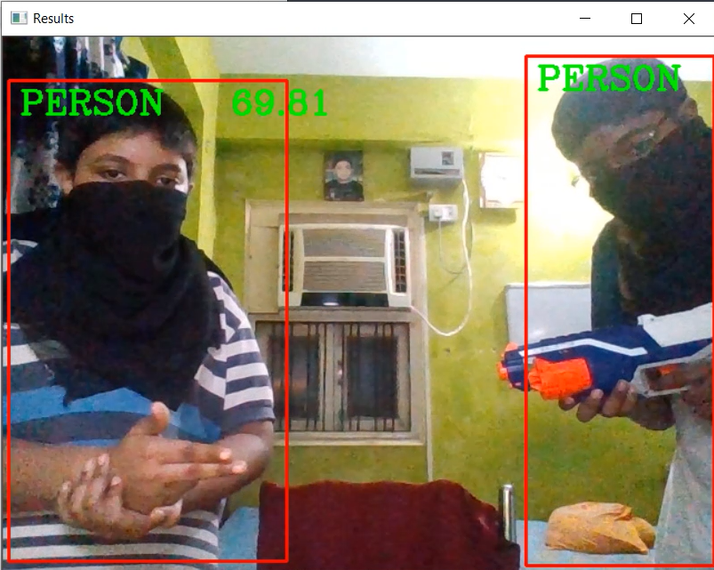
[Robber Detection]

- Faint Detection
This feature can detect and identify if some one has fainted then it can inform the family members and call the hospital if needed.
Using Pose Estimation it identifies the posture of the body then using Algorithms it detects if a person has fell on the ground or not. This is especially useful for old people who are more prone to faint and they mostly spend their time alone in homes. 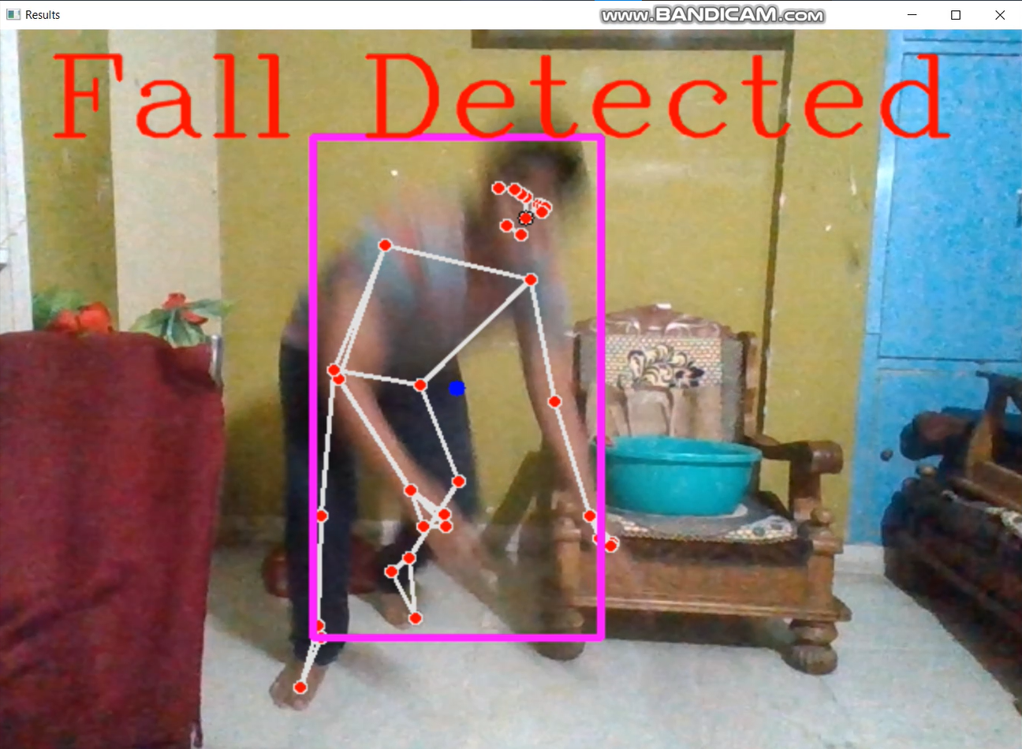

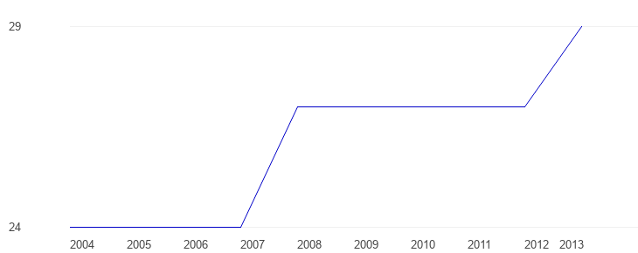Thefts per 100,000 people, 2004 - 2013^{[iii]}
The chart clearly shows the sudden increase in the theft rate in India. This also tells that the Next Gen Camera is so much important today.

AIMS AND OBJECTIVES OF THE STUDY

- To collect information regarding security status against fire accidents and robbery in Patna via survey.
- To design an AI camera
- To enable AI Camera to detect objects and persons
- To develop a Next Gen camera to provide real-time security to increase the standard of living.

HYPOTHESIS
Imagine a robber robbing a flat of a middle-class family leaving in a moderate society. In spite of having security cameras even if we record the robbery event, we won’t be able to do much with it after the robbery took place. Even though we spend money on security guards.
Imagine an incense stick just drops down on a mat and it slowly catches fire then slowly starts to burn your curtain. Your innocent CCTV camera is recording your house burning down and can’t do anything. I think we all know further what can happen and no one wants that disaster.
We thought about this scenario and asked ourselves, what would be an easily accessible way for the masses to fight against this problem. This was our idea for the Next Gen Camera and its hypothesis went like this.
- Next Gen Camera helps in robber detection with an alarm system which leads to cost-efficient security against robbery.
- Next Gen Camera helps in fire detection with an alarm system which leads to cost-efficient security against fire.
Addition after judges’ feedback:
- Next Gen Camera helps in Gun/ weapon detection with buzzer sound which leads to cost-efficient security.
- Next Gen Camera helps in detecting people being faint with an alarm system which leads to alerting people around.
- Next Gen Camera helps in informing concerned people via messages and phone calls in real-time which leads to cost-efficient security against wrong events.
- Next Gen Camera helps in finding suspects or criminals by face recognition using public cameras and informing the police about their last seen location.

NEED STATEMENT

- After seeing the Problems in today ‘life, we see in our society, we thought to contribute and after discussing robberies and fire accidents with my friend and our guide teacher, we came up with the idea to develop this kind of camera which is sustainable.
- We were also worried about the amount of money people have to spend on security.

- Therefore, there is a need to design and develop AI enabled camera to get security against loss due to uncertain wrong event by detecting & providing information to the right people at the right time and thereby saving people, money, property etc.

WORK PLAN

This project can be broken into a couple of parts
- Idea generation by exploring needs and problems in the society
- Developing questionnaire, data collection, and observation
- Thinking of how will we implement Next Gen Camera
- Coding
- The model making, charts, etc. to present the concept
- Report writing

METHODOLOGY
Research method:
Survey via a well-structured questionnaire consisting of 30 items
- The Questions that were structured have been used to identify various factors mentioned in the hypothesis.
- Data has been collected using Primary and Secondary Sources.
- Plan of Collecting Primary Data: Primary data has been collected using survey methods.
- Secondary Data has been collected from research papers, books, and the internet.
- The sample size consisted of 50 individuals belonging to different parts of the world.
Software development:
- For making the system that is the Main Artificial Intelligence (AI), we used Python Programming Language for making it.
- It all works on the system of Neural Networks. Here we train the AI with different images of objects to find characteristics in them. Then it can recognize those objects by matching characters with their gained knowledge.
- Our Brain also works in the same manner where after seeing an object we can identify that and get better at recognizing that if we see that object more times. In the same way, we have to train the AI with so many images that it gets very accurate in recognizing that object.
- Most difficulty while making the AI is collecting the right dataset that collection of images. It sounds easy on paper but slowly gets tougher. There are many algorithms to choose from.
- There were also many public datasets and models that we used to train our AI. Training the AI took hours and many failures and different ways were discovered. During this process, we also learned a lot of things about and are much more confident to add new features. Making the entire system took days and nights.
Models & Chart Development
We have also prepared a physical model to depicts the few circumstances that where and how our Next Gen Camera will be used.

OBSERVATIONS

PRE-PROJECT SURVEY

For this project, we have prepared a questionnaire.
      - Do you have many CCTV Camera/s installed in your residence ?
A) YES B) NO
2. Have you ever faced any kind of Fire Accident ?
A) YES B) NO
3. Has there ever been any robbery/kidnapping or anti-social activities in your locality?
A) YES B) NO
4. Are you interested in a system with AI-enabled Robber Detection using CCTV cameras to alert on an
A) YES B) NO
anonymous entry when entry is not allowed?
A) YES B) NO C) Maybe
5. Are you interested in a system with Al Fire Detection using only CCTV cameras that will alert on Fire happenings? Such to protect the lives and capital of people.
A) YES B) NO C) Maybe
After the collecting the survey details, we gathered the results. They are shown below using pie charts.

POST PROJECT SURVEY :
After making this project, we have again done a small survey by showing the working of the next gen camera to our respondent.
1. Do you know about Artificial Intelligence enabled CCTV cameras ?
A) YES B) NO
2. Which feature did you like the most ?
A) ROBBER DETECTION
B) Fire DETECTION
C) FAINT DETECTION
D) FACE RECOGNITION
E) All of the above
3. How much money are you willing to spend on such a product for the safety and security of your loved ones and belongings?
A) Below Rs, 1000
B) Rs. 1000 to Rs, 2000
C) Above Rs. 2000
4. How much money do you spend on security per month? (Guards, Fire Safety equipment like smoke detectors, etc., sensors, and CCTV cameras).
A) Less than Rs, 500
B) Rs. 500 – Rs. 2000
C) Rs. 2000 – Rs. 5000
D) Over Rs. 5000
Followings are the findings :

RESULTS
After making the project we tested it in our homes and found bugs (problems) which were fixed and slowly made our system better. We tried to use it as simple as a normal person would try to use it. We made the user interface much more interactive for easy usage.
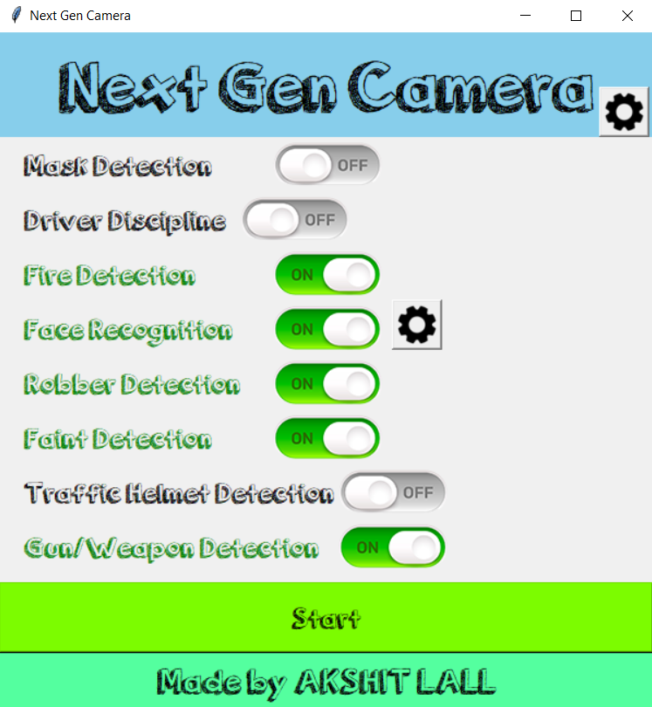
[User interface]
We also prepared physical models of small rooms in which we can demonstrate fire detection

IMPROVEMENT AFTER THE FEEDBACK FROM JUDGES[1]:

- As suggested by our judges to add Gun detection along with robber, we acted accordingly.
- We have seen in Banks and Jewelry shops when the robber comes, they show a gun to scare the shopkeepers or bank officials. We trained our AI with images of weapons to help it find characteristics in the object, therefore matching it on different objects to find similar weapons/guns.
- Judges also suggested adding a phone call system to alert the owner as soon as the event took place. This Phone call will also go to the police station or Fire Extinguishers or the owner as per situations. Using an external API we can make calls.
- While working on the ideas suggested by the judges, we have also found another idea of faint detection.
- There are many cases where people faint due to health issues. Especially when someone staying alone like an elderly person, and there is no one to help, we can use the Next Gen Camera to detect if someone has fainted. Elderly people are more likely to faint but it may happen to anybody. There are also cases when they are alone and that might be deadly. But using Next Gen cameras we can be informed if someone has fainted therefore informing the owner by calling or informing neighbors.
- By Analyzing our Projects, we also tried to find as many disadvantages as possible to remove them such as adding an inbuilt power backup system to support even electricity failure. This will help the system to resist this kind of uncontrolled event.
- We also added the feature of detecting anomalies like if a robber tries to cover the camera with clothes.
- Public Cameras can be also used to find criminals by Face Recognition. The suspects which the police are trying to find, their photos will be given to the AI and if those faces are found from the list, he/she will be caught by informing the police. There can be a common database for a local area to find suspects. This can increase the efficiency of officials to catch wrong persons. This can be also be used in cameras of shops and in return they can get some advantage if because of them a criminal is caught.
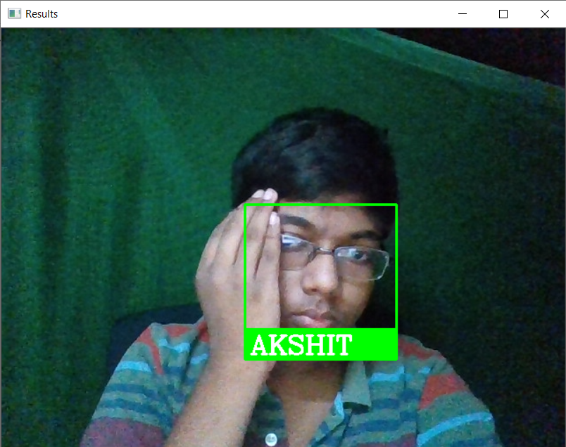
Face Recognition example ( for catching criminals / Suspects )

IMPROVEMENT AFTER THE FEEDBACK FROM JUDGES [2]:

- We improved our project by creating a Mobile App using which users can also toggle the features even if they are not at home. It will improve the ease of access and make it more user friendly.
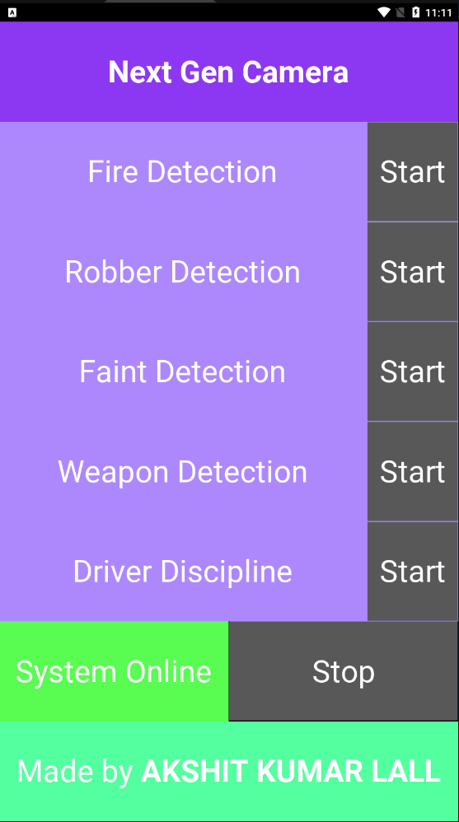
Our Self made Mobile App Running on Phone

- Recently Road Accidents are growing as they drivers are not keeping attention. Using a camera mounted on the deck we can detect many things. Such as if a person is feeling drowsy or sleepy which should be highly avoided, or a person is not looking towards the road or talking with his phone will talking.
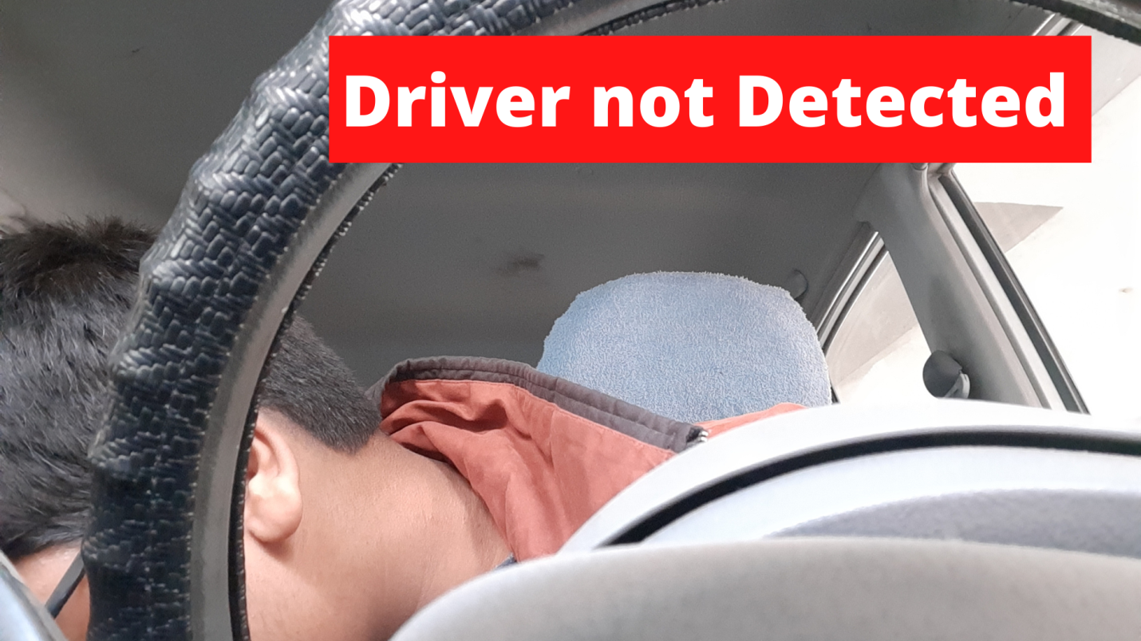
Driver Discipline
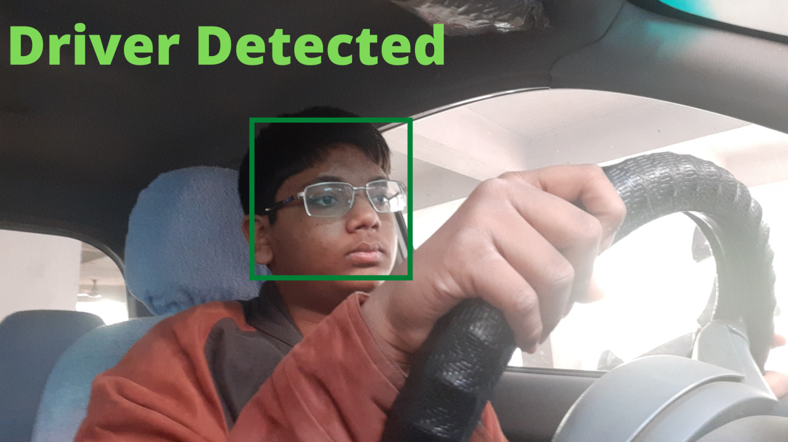
Driver Discipline
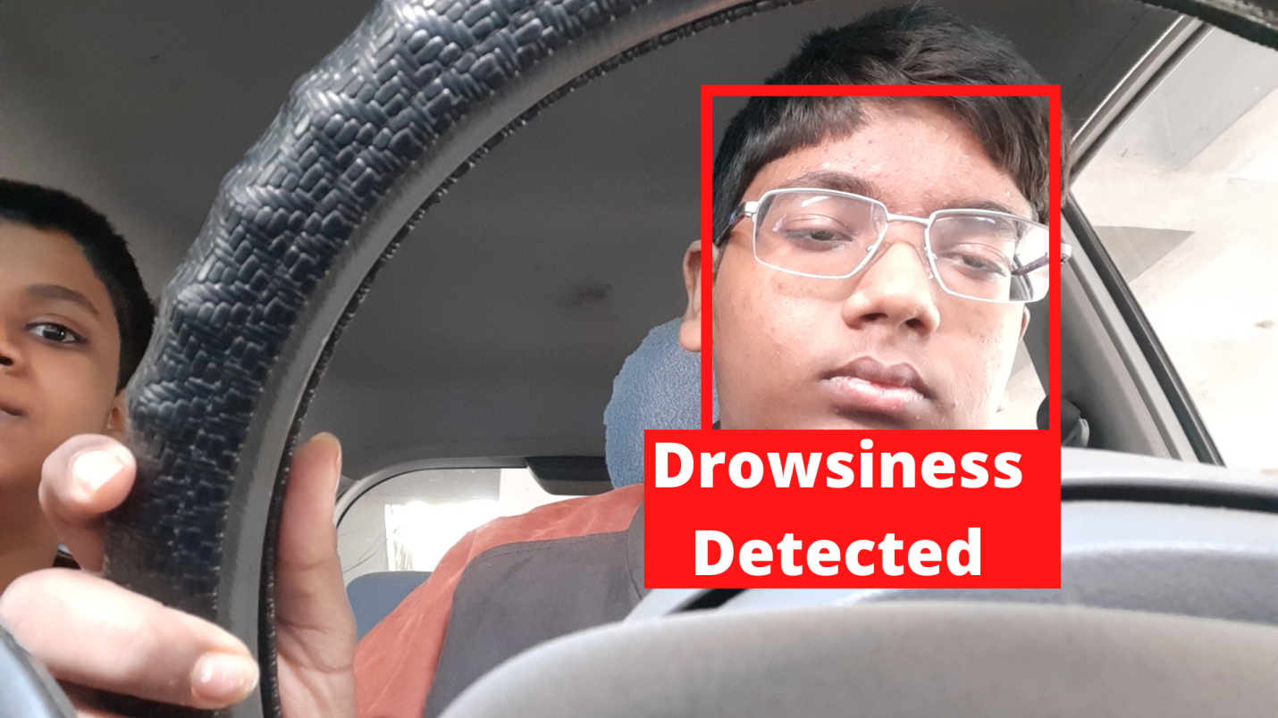
Driver Discipline
- We also improved the AI and made it better by optimizing the code.

CONCLUSION:

As greatly said
“Precaution is better than Cure.”

- We should try to take as much as precautions as possible along with keeping with sustainability and that must be feasible for everyone.
- Next Gen Camera is the solution of the problem of loss due to uncertain wrong event by detecting & providing information to the right people at the right time and thereby saving people, money, property, etc.
- We want to develop this project much further and make it available to all. This will also bring greater impact to society on a Bigger Picture. Slowly People with low income will start getting secure and also save money that was being used in Security. That will also decrease robberies and loss of infrastructure in fire accidents.

FUTURE PLAN:

This is not the end; everything can improve and there’s still a lot to go.
In the future, we will add features like:
- Traffic Helmet Detection will identify helmets on a person’s head and if a person has no helmet on their head, then an e- challan will be sent to its corresponding vehicle number or inform the traffic police at the center of the round-about. Therefore, AI along with the camera that is Computer Vision can bring revolutions
- Realtime Fare Evasion Detection
Cameras can also be used to maintain discipline in society. In case of Invasions from boundaries or fare evasion in public places, Guards cannot be present everywhere. But by using Artificial Intelligence, the AI can predict the pose, body posture to identify these actions. It can identify different points on our body and check if the values of the joints represent a wrong posture.

Use of Old Smart Phones:
SmartPhones are present everywhere today. and old smartphones don’t have any place to go rather than the landfills or people’s cupboards and drawers, making it e-waste.
Still, middle-class or low-class families can not afford to take out money to buy even a CCTV camera setup. But using old phones that are just thrown away, we can use the components to build our Next Gen Camera, our project.

A normal Smart Phone has a Camera, CPU for processing, and other things. The inbuilt camera can be extracted and the CPU can be used to build a setup box that can load the Artificial Intelligence software into it.
Therefore making our Project (Next Gen Camera) more sustainable by making it Low Cost, removing e-waste ( old smartphones ), and not consuming new materials like iron and silicon that are also limited and non-renewable. Including this can make our project the most sustainable.
As India is a developing country, we can not afford to invest our money in these things as we have many other sectors to manage like health and education. By using e-waste to make new things we are indirectly supporting our economy by consuming less money and energy.

ACKNOWLEDGMENT:

We give our utmost gratitude to our guide teacher Satya Prakash Sir who keep on motivating us as a teacher/ mentor/ guide and also a good friend. Sir has made it possible to prepare this project by giving many challenges and benchmarks to overcome.

This project also wouldn’t have been possible without our parents for constant support and giving us the time and freedom to work on this project for countless hours.

REFERENCES :

https://ncrb.gov.in/sites/default/files/adsi2020_Chapter-1-Accidents.pdf [i]
https://factly.in/number-of-fire-accidents-in-the-country-reduced-over-time/ [ii]
https://www.theglobaleconomy.com/India/theft/ [iii]
https://www.youtube.com/c/MurtazasWorkshopRoboticsandAI/videos [for learning concepts and programming ]

Python Program
of
NEXT GEN CAMERA

All the Codes written for Next Gen Camera till now (by Akshit Kumar Lall):

- Main.py (the main file)
import cv2
# import numpy as np
from tkinter import *
from tkinter.filedialog import asksaveasfile, askopenfile
from tkinter import messagebox
import os
from src.face_recog import FaceRecognition
from src.motionDec import MotionDetection
from src.objDec import ObjectDetectionSSD, ObjectDetectionYOLO
from src.haarcascade import HaarCascade
import shutil
import sys
import signal
from plyer import notification
import serial
from cvzone.PoseModule import PoseDetector
from detecto import core
from src.classifier import Classifier
import numpy as np
from twilio.rest import Client

class FireDec():
def __init__(self):
self.model, self.classes, self.colors, self.output_layers = self.load_yolo()

def draw_labels(self, boxes, confs, colors, class_ids, classes, img):
indexes = cv2.dnn.NMSBoxes(boxes, confs, 0.5, 0.4)
font = cv2.FONT_HERSHEY_PLAIN
for i in range(len(boxes)):
if i in indexes:
x, y, w, h = boxes[i]
label = str(classes[class_ids[i]])
color = colors[i]
cv2.rectangle(img, (x, y), (x+w, y+h), color, 2)
cv2.putText(img, label, (x, y - 5), font, 1, color, 1)
img = cv2.resize(img, (800, 600))
cv2.imshow("Image", img)

def load_yolo(self):
net = cv2.dnn.readNet("yolov3.weights", "yolov3.cfg")
classes = []
with open("obj.names", "r") as f:
classes = [line.strip() for line in f.readlines()]

layers_names = net.getLayerNames()
output_layers = [layers_names[i[0]-1]
for i in net.getUnconnectedOutLayers()]
colors = np.random.uniform(0, 255, size=(len(classes), 3))
return net, classes, colors, output_layers

def detect_objects(self, img, net, outputLayers):
blob = cv2.dnn.blobFromImage(img, scalefactor=0.00392, size=(
320, 320), mean=(0, 0, 0), swapRB=True, crop=False)
net.setInput(blob)
outputs = net.forward(outputLayers)
return blob, outputs

def get_box_dimensions(self, outputs, height, width):
boxes = []
confs = []
class_ids = []
for output in outputs:
for detect in output:
scores = detect[5:]
class_id = np.argmax(scores)
conf = scores[class_id]
if conf > 0.3:
center_x = int(detect[0] * width)
center_y = int(detect[1] * height)
w = int(detect[2] * width)
h = int(detect[3] * height)
x = int(center_x - w/2)
y = int(center_y - h / 2)
boxes.append([x, y, w, h])
confs.append(float(conf))
class_ids.append(class_id)
return boxes, confs, class_ids

def detect(self, img, debug):
img = cv2.resize(img, (800, 600))
model, classes, colors, output_layers = self.load_yolo()

height, width, channels = img.shape
blob, outputs = self.detect_objects(img, model, output_layers)
boxes, confs, class_ids = self.get_box_dimensions(
outputs, height, width)
if debug:
self.draw_labels(boxes, confs, colors, class_ids, classes, img)

if 1 in class_ids:
return True
else:
return False

try:
ser = serial.Serial('COM6', 9600)
except Exception as error:
print(error)
ser = None

model = core.Model.load('data/model_weights.pth', ['person', 'helmet', 'head'])

MD = MotionDetection()
HC = HaarCascade("data/FireDetection/fire_detection.xml")
FR = FaceRecognition("data/FaceRecognition/images")
ODS = ObjectDetectionSSD()
PD = PoseDetector()
GD = ObjectDetectionYOLO(modelConfiguration="data/YOLO Models/yolov3.cfg",
modelWeights="data/YOLO Models/yolov3.weights",)
# GD.swapRB = True
# GD.scaleFactor = 0.00392

mask_classifier = Classifier('data/keras_model.h5', 'data/labels.txt')

buzzerOn = 0
firetimer = 0
cam_id = 0

account_sid = "ACdf3e5ec9e897bce41a367960fffb6d76"
auth_token = "efb4e6e579e5edb58f67e5b625667ded"

client = Client(account_sid, auth_token)

def saveImage(img):
files = [("JPG Files", "*.jpg")]
file = asksaveasfile(filetypes=files, defaultextension=files)

if not file or not os.path.exists(file.name):
return None

cv2.imwrite(file.name, img)

def checkAlarm():
global alarm, alarm_medium, buzzerOn, alarm_for

try:
if alarm_medium:
medium = alarm_medium_type_options.get().index(alarm_medium.get())
else:
medium = 1
except:
medium = 3

# do actions
if medium == 1:
# notification.notify(
# title="Something Detected ",
# message="There is some Issue. Something detected. Kindly PANIC FAST",
# # displaying time
# timeout=20,
# app_name="Camera 2.0",
# app_icon="data/favicon.ico",
# )

messagebox.showwarning(
"Something Detected !!",
"There is some Issue. Something detected. Kindly PANIC FAST",
)
elif medium == 2:
# send_mail()

call = client.calls.create(
to="+91 87893 99449",
from_="+1 318 515 1944",
url="https://demo.twilio.com/docs/voice.xml"
)
print(call, '\n', call.sid)
pass
elif medium == 3 and ser:
ser.write(str('2').encode())
print(ser.readline().decode())
buzzerOn = 100
if alarm_for == "fire":
ser.write(str('4').encode())
print(ser.readline().decode())

alarm = False

y1 = [0, 0]
time = 0

def main():
global alarm, alarm_timer, buzzerOn, firetimer, alarm_for, cam_id, gunDecEnabled

alarm_timer = 0

cap = cv2.VideoCapture(cam_id)

while True:
suc, img = cap.read()

if alarm and alarm_timer <= 0:
alarm_timer = 40
checkAlarm()

# if buzzerOn <= 0 and buzzerOn != 1.12340909 and not alarm and ser:
# ser.write(str('3').encode())
# print(ser.readline().decode())
# if alarm_for == "fire":
# ser.write(str('4').encode())
# print(ser.readline().decode())
# buzzerOn = 1.12340909

# print(alarm_timer, buzzerOn)

if buzzerOn > 0 and buzzerOn != 1.12340909:
buzzerOn -= 1
if alarm_timer > 0:
alarm_timer -= 1

if not suc:
messagebox.showerror("Camera : Not Able to Open",
"Please Check your camera")
print(f"Trying with {cam_id-1}")
cam_id -= 1
break

if motionDecEnabled:
MD.detect(img, draw=debug)
if haarcascadeEnabled:
_, boolean = HC.detect(img, draw=debug)
# boolean = FD.detect(img, debug)
if boolean and firetimer >= 2:
# ser.write(str('4').encode())
alarm = True
if not boolean and not firetimer <= 0:
firetimer -= 1
if firetimer <= 0:
alarm = False
alarm_for = "fire"
if firetimer <= 2 and boolean:
firetimer += 1

# print(firetimer)

if faceRecogEnabled:
FR.detect(img)
if personDecEnabled:
classIds, confs, bbox = ODS.detect(img, draw=False)
for i in range(len(classIds)):
if classIds[i] == 1:
alarm = True
alarm_for = "robber"
cv2.rectangle(img, bbox[i], (0, 0, 255), 2)
cv2.putText(img, "Robber", (bbox[i][0] + 10, bbox[i][1] + 30), cv2.FONT_HERSHEY_COMPLEX, 1, (255, 0, 0), 2,
)
if poseDecEnabled:
img = PD.findPose(img)
lmList, bboxInfo = PD.findPosition(img)
if bboxInfo:
# print('\n\n\n\n\n', lmList, '\n', bboxInfo)
# for l in lmList:
# cv2.putText(img, str(l[0]), (l[1], l[2]),
# cv2.FONT_HERSHEY_COMPLEX, 0.5, (255, 255, 0))

y = lmList[0][2] * img.shape[0]
y1.append(y)
print((y - y1[-2]))
if (y - y1[-2]) > 7000:
cv2.putText(img, "Fall Detected", (20, 50),
cv2.FONT_HERSHEY_COMPLEX, 2.5, (0, 0, 255), 2, 11)

if helmetDecEnabled:
labels, boxes, scores = model.predict(img)
for l, b, s in zip(labels, boxes, scores):
print(s)
x, y, w, h = b
if x > 0 and y > 0 and w > 0 and h > 0 and s > 0:
print(l)
cv2.putText(img, l, (int(x), int(y)),
cv2.FONT_HERSHEY_SIMPLEX, 1, (255, 0, 255), 2)
cv2.rectangle(img, (int(x), int(y)),
(int(w), int(h)), (255, 0, 0), 2)

if maskDetectionEnabled:
res = mask_classifier.getPrediction(img)

if gunDecEnabled:
GD.detect(img, debug)

cv2.imshow("Results", img)
k = cv2.waitKey(1) & 0xFF
if k == 27:
if ser:
ser.write(str('3').encode())
print(ser.readline().decode())
break
elif k == ord("s"):
saveImage(img)
elif k == ord('z'):
ser.write(str('4').encode())
# ser.write(str('4').encode())
print(ser.readline().decode())
elif k == ord('c'):
ser.write(str('3').encode())
print(ser.readline().decode())

cap.release()
cv2.destroyAllWindows()
cv2.waitKey(1)

# ------------------------------------ GUI ------------------------------------

def maskButtonFunc():
global maskDetectionEnabled
# Determin is on or off
if maskDetectionEnabled:
maskButton.config(image=off)
maskLabel.config(fg="black")
# debug = False
maskDetectionEnabled = False
else:
maskButton.config(image=on)
maskLabel.config(fg="green")
maskDetectionEnabled = True

def motionDecButtonFunc():
global motionDecEnabled
# Determin is on or off
if motionDecEnabled:
motionDecButton.config(image=off)
motionDecLabel.config(fg="black")
motionDecEnabled = False
else:
motionDecButton.config(image=on)
motionDecLabel.config(fg="green")
motionDecEnabled = True

def haarcascadeButtonFunc():
global haarcascadeEnabled
# Determin is on or off

if haarcascadeEnabled:
haarcascadeButton.config(image=off)
haarcascadeLabel.config(fg="black")
haarcascadeEnabled = False
else:
haarcascadeButton.config(image=on)
haarcascadeLabel.config(fg="green")
haarcascadeEnabled = True

def faceRecogButtonFunc():
global faceRecogEnabled
# Determin is on or off

if faceRecogEnabled:
faceRecogButton.config(image=off)
faceRecogLabel.config(fg="black")
faceRecogEnabled = False
else:
faceRecogButton.config(image=on)
faceRecogLabel.config(fg="green")
faceRecogEnabled = True

def addImages():
global FR
file = askopenfile(
mode="r",
filetypes=[
("PNG Files", "*.png"),
("JPG Files", "*.jpg"),
("JPEG Files", "*.jpeg"),
],
)
if not file:
return

print(file.name)
try:
string = str(file.name).split("/")[-1]
shutil.copy(file.name, save_image_path)
messagebox.showinfo(
"Sucessfull", "Sucessfully Added Image for Face Recognition"
)
except Exception as error:
print(error)
messagebox.showerror("Failure", "Moving Image Failed")

try:
del FR
FR = FaceRecognition("data/FaceRecognition/images")
except Exception as error:
print(error)

def faceRecogSettingsButtonFunc():
r = Tk()
r.title("Face Recognition Settings")
r.geometry("500x500")
Label(
r, text="Add Face Recognition Images", font=(fontName, 20), bg="SeaGreen1"
).pack(fill="x")

Button(
r, command=addImages, text="Browse", font=(fontName, 20), bg="lawn green"
).pack(pady=20)

r.mainloop()

def personDecButtonFunc():
global personDecEnabled
# Determin is on or off

if personDecEnabled:
personDecButton.config(image=off)
personDecLabel.config(fg="black")
personDecEnabled = False
else:
personDecButton.config(image=on)
personDecLabel.config(fg="green")
personDecEnabled = True

def poseDecButtonFunc():
global poseDecEnabled
# Determin is on or off

if poseDecEnabled:
poseDecButton.config(image=off)
poseDecLabel.config(fg="black")
poseDecEnabled = False
else:
poseDecButton.config(image=on)
poseDecLabel.config(fg="green")
poseDecEnabled = True

def helmetDecButtonFunc():
global helmetDecEnabled
# Determin is on or off

if helmetDecEnabled:
helmetDecButton.config(image=off)
helmetDecLabel.config(fg="black")
helmetDecEnabled = False
else:
helmetDecButton.config(image=on)
helmetDecLabel.config(fg="green")
helmetDecEnabled = True

def gunDecButtonFunc():
global gunDecEnabled
# Determin is on or off

if gunDecEnabled:
gunDecButton.config(image=off)
gunDecLabel.config(fg="black")
gunDecEnabled = False
else:
gunDecButton.config(image=on)
gunDecLabel.config(fg="green")
gunDecEnabled = True

def on_closing():
# if messagebox.askokcancel("Quit", "Do you want to quit?"):
# root.destroy()
root.destroy()
print("Closing System...")
os.kill(os.getpid(), signal.SIGTERM)
sys.exit()

def open_main_settings():
global alarm_medium, alarm_medium_type_options

settings_root = Tk()
alarm_medium = StringVar(settings_root, value=alarm_medium_type_options[0])

x_Left = int(settings_root.winfo_screenwidth() / 2 - windowWidth / 2)
y_Top = int(settings_root.winfo_screenheight() / 2 - windowHeight / 2)

settings_root.geometry(f"{windowWidth}x{windowHeight}")
settings_root.geometry("+{}+{}".format(x_Left, y_Top))

settings_root.title("Main Settings")

alarmMediumButton = hrs = OptionMenu(
settings_root, alarm_medium, *alarm_medium_type_options
)
hrs.config(font=(fontName, 20))

alarmMediumButton.place(x=250, y=100)
alarmMediumLabel = Label(
settings_root, text="Alarm Medium", fg="black", font=(fontName, 20)
)
alarmMediumLabel.place(x=20, y=100)

settings_root.mainloop()

alarm = False
alarm_for = None
windowWidth = 600
windowHeight = 600
fontName = "orange juice"
title = "Next Gen Camera"
GUI_ImagePath = "data/gui/images/"
save_image_path = "data/FaceRecognition/images"
motionDecEnabled = False
alarmEnabled = False
debug = True
faceRecogEnabled = False
haarcascadeEnabled = False
personDecEnabled = False
poseDecEnabled = False
maskDetectionEnabled = False
helmetDecEnabled = False
gunDecEnabled = False

root = Tk()

on = PhotoImage(file=GUI_ImagePath + "on.png")
off = PhotoImage(file=GUI_ImagePath + "off.png")
settings_icon = PhotoImage(file=GUI_ImagePath + "settingsIcon.png")

alarm_medium_type_options = ["Notifications", "Email", "Speaker"]

x_Left = int(root.winfo_screenwidth() / 2 - windowWidth / 2)
y_Top = int(root.winfo_screenheight() / 2 - windowHeight / 2)

root.geometry(f"{windowWidth}x{windowHeight}")
root.geometry("+{}+{}".format(x_Left, y_Top))

root.title(title)

root.protocol("WM_DELETE_WINDOW", on_closing)

Label(root, font=(fontName, 50), text=title,
bg="sky blue").pack(fill="x", side=TOP)
Button(
root, image=settings_icon, font=(fontName, 10), command=open_main_settings
).place(x=550, y=50)

Label(root, font=(fontName, 25), text="Made by AKSHIT LALL", bg="SeaGreen1").pack(
fill="x", side=BOTTOM
)

maskButton = Button(root, image=off, bd=0, command=maskButtonFunc)
maskButton.place(x=250, y=100)
maskLabel = Label(root, text="Mask Detection", fg="black", font=(fontName, 20))
maskLabel.place(x=20, y=100)

motionDecButton = Button(root, image=off, bd=0, command=motionDecButtonFunc)
motionDecButton.place(x=220, y=150)
motionDecLabel = Label(root, text="Driver Discipline",
fg="black", font=(fontName, 20))
motionDecLabel.place(x=20, y=150)

haarcascadeButton = Button(root, image=off, bd=0,
command=haarcascadeButtonFunc)
haarcascadeButton.place(x=250, y=200)
haarcascadeLabel = Label(root, text="Fire Detection",
fg="black", font=(fontName, 20))
haarcascadeLabel.place(x=20, y=200)

faceRecogButton = Button(root, image=off, bd=0, command=faceRecogButtonFunc)
faceRecogButton.place(x=250, y=250)
faceRecogSettingsButton = Button(
root, image=settings_icon, font=(fontName, 10), command=faceRecogSettingsButtonFunc
)
faceRecogSettingsButton.place(x=360, y=245)
faceRecogLabel = Label(root, text="Face Recognition",
fg="black", font=(fontName, 20))
faceRecogLabel.place(x=20, y=250)

personDecButton = Button(root, image=off, bd=0, command=personDecButtonFunc)
personDecButton.place(x=250, y=300)
personDecLabel = Label(root, text="Robber Detection",
fg="black", font=(fontName, 20))
personDecLabel.place(x=20, y=300)

poseDecButton = Button(root, image=off, bd=0, command=poseDecButtonFunc)
poseDecButton.place(x=250, y=350)
poseDecLabel = Label(root, text="Faint Detection",
fg="black", font=(fontName, 20))
poseDecLabel.place(x=20, y=350)

helmetDecButton = Button(root, image=off, bd=0, command=helmetDecButtonFunc)
helmetDecButton.place(x=310, y=400)
helmetDecLabel = Label(root, text="Traffic Helmet Detection",
fg="black", font=(fontName, 20))
helmetDecLabel.place(x=20, y=400)

gunDecButton = Button(root, image=off, bd=0, command=gunDecButtonFunc)
gunDecButton.place(x=310, y=450)
gunDecLabel = Label(root, text="Gun/Weapon Detection",
fg="black", font=(fontName, 20))
gunDecLabel.place(x=20, y=450)

Button(root, font=(fontName, 20), text="Start", bg="lawn green", command=main).pack(
fill="x", side=BOTTOM
)

root.mainloop()

ser.write(str('3').encode())
print(ser.readline().decode())

ser.close()

exit()

- Face_recog.py
import cv2
import numpy as np
import face_recognition
import os

class FaceRecognition:
def __init__(self, path):

self.path = path
self.images = []
self.classNames = []

myList = os.listdir(path)

for name in myList:
img = cv2.imread(os.path.join(self.path, name))
self.images.append(img)
self.classNames.append(os.path.splitext(name)[0])

self.encodeList = self.findEndcodings(self.images)

def findEndcodings(self, images):
encodeList = []
for img in images:
img = cv2.cvtColor(img, cv2.COLOR_BGR2RGB)
encode = face_recognition.face_encodings(img)[0]
encodeList.append(encode)

return encodeList

def detect(self, img, draw=True):
faces = []
imgS = cv2.resize(img, (0, 0), None, 0.25, 0.25)
imgS = cv2.cvtColor(imgS, cv2.COLOR_BGR2RGB)

faceLoc = face_recognition.face_locations(imgS)
encode = face_recognition.face_encodings(imgS, faceLoc)

for encodeFace, faceLoc in zip(encode, faceLoc):
matches = face_recognition.compare_faces(self.encodeList, encodeFace)
faceDis = face_recognition.face_distance(self.encodeList, encodeFace)
# print(matches , faceDis)

matcheIndex = np.argmin(faceDis)
if matches[matcheIndex]:
name = self.classNames[matcheIndex].upper()
y1, x2, y2, x1 = faceLoc
y1, x2, y2, x1 = y1 * 4, x2 * 4, y2 * 4, x1 * 4

faces.append([str(name), (x1, y1), (x2, y2)])

if draw:
cv2.rectangle(img, (x1, y1), (x2, y2), (0, 255, 0), 2)
cv2.rectangle(img, (x1, y2 - 35), (x2, y2), (0, 255, 0), cv2.FILLED)
# cv2.putText(img , str(name) , (x1 , y2 - 35) , cv2.FONT_HERSHEY_COMPLEX , 1 , (0,255,0) , 2)
cv2.putText(
img,
str(name),
(x1 + 6, y2 - 6),
cv2.FONT_HERSHEY_COMPLEX,
1,
(255, 255, 255),
2,
)

return faces

if __name__ == "__main__":
cap = cv2.VideoCapture(0)

fr = FaceRecognition("data/FaceRecognition/images")

while cap.isOpened():
suc, img = cap.read()

face = fr.detect(img)

cv2.imshow("Results", img)
k = cv2.waitKey(1)
if k == 27:
break

cap.release()
cv2.destroyAllWindows()

- Motion_Dec.py
import cv2

class MotionDetection():
def __init__(self , detectionVal=500 , thresh=25, blurVal=(21,21)):
self.firstFrame = None
self.thresh = thresh
self.blurVal = blurVal
self.detectionVal = detectionVal

def setfirstFrame(self , img):
if self.firstFrame is None:
self.firstFrame = img

def detect(self , img , draw=True):

gray = cv2.cvtColor(img, cv2.COLOR_BGR2GRAY)
gray = cv2.GaussianBlur(gray, self.blurVal, 0)

self.setfirstFrame(gray)

delta_frame = cv2.absdiff(self.firstFrame , gray)
threshold = cv2.threshold(delta_frame , self.thresh , 255 , cv2.THRESH_BINARY)[1]
threshold_frame = cv2.dilate(threshold , None , iterations=2)

cntr , _ = cv2.findContours(threshold_frame.copy() , cv2.RETR_EXTERNAL , cv2.CHAIN_APPROX_SIMPLE)

self.firstFrame = gray

motion = []
for contour in cntr:
if cv2.contourArea(contour) < self.detectionVal :
continue

x,y,w,h = cv2.boundingRect(contour)
motion.append([x,y,w,h])
if draw : cv2.rectangle(img , (x,y) , (x+w,y+h) , (0,255,0) , 3)

return img , motion

if __name__ == '__main__':

cap = cv2.VideoCapture(0)

MD = MotionDetection()

while True:
suc , img = cap.read()

MD.detect(img)

cv2.imshow("Results" , img)
k = cv2.waitKey(1)

if k == 113 or k == 27 : break

cap.release()
cv2.destroyAllWindows()
- Obj Dec.py
import cv2
import numpy as np
import sys

class ObjectDetectionSSD:
def __init__(
self,
use_gpu=True,
configPath="data/SSD models/ssd_mobilenet_v3_large_coco_2020_01_14.pbtxt",
weightsPath="data/SSD models/frozen_inference_graph.pb",
classFile="data/coco.names",
):
self.thres = 0.55 # Threshold to detect object

self.classNames = []
with open(classFile, "rt") as f:
self.classNames = f.read().rstrip("\n").split("\n")

self.net = cv2.dnn_DetectionModel(weightsPath, configPath)
self.net.setInputSize(320, 320)
self.net.setInputScale(1.0 / 127.5)
self.net.setInputMean((127.5, 127.5, 127.5))
self.net.setInputSwapRB(True)

if use_gpu:
self.net.setPreferableBackend(cv2.dnn.DNN_BACKEND_CUDA)
self.net.setPreferableTarget(cv2.dnn.DNN_TARGET_CUDA)

def detect(self, img, draw=True):
classIds, confs, bbox = self.net.detect(img, confThreshold=self.thres)
# print(classIds,bbox)

if len(classIds) != 0:
for classId, confidence, box in zip(
classIds.flatten(), confs.flatten(), bbox
):
# print(classNames[classId-1].upper())
if draw:
cv2.rectangle(img, box, color=(0, 255, 0), thickness=2)
cv2.putText(
img,
self.classNames[classId - 1].upper(),
(box[0] + 10, box[1] + 30),
cv2.FONT_HERSHEY_COMPLEX,
1,
(0, 255, 0),
2,
)
cv2.putText(
img,
str(round(confidence * 100, 2)),
(box[0] + 200, box[1] + 30),
cv2.FONT_HERSHEY_COMPLEX,
1,
(0, 255, 0),
2,
)

return classIds, confs, bbox

class ObjectDetectionYOLO:
def __init__(
self,
modelConfiguration="data/YOLO Models/320/yolov3-320.cfg",
modelWeights="data/YOLO Models/320/yolov3.weights",
classesFile="data/coco.names",
use_gpu=True,
):
self.whT = 320
self.confThreshold = 0.5
self.nmsThreshold = 0.2
self.swapRB = False
self.scaleFactor = 1 / 255

self.classNames = []
with open(classesFile, "rt") as f:
self.classNames = f.read().rstrip("\n").split("\n")

self.net = cv2.dnn.readNetFromDarknet(modelConfiguration, modelWeights)

if use_gpu:
self.net.setPreferableBackend(cv2.dnn.DNN_BACKEND_CUDA)
self.net.setPreferableTarget(cv2.dnn.DNN_TARGET_CUDA)

def detect(self, img, draw=True):
blob = cv2.dnn.blobFromImage(
img, self.scaleFactor, (self.whT, self.whT), [0, 0, 0], 1, crop=False, swapRB=self.swapRB
)
self.net.setInput(blob)
layersNames = self.net.getLayerNames()
outputNames = [
(layersNames[i[0] - 1]) for i in self.net.getUnconnectedOutLayers()
]
outputs = self.net.forward(outputNames)
hT, wT, cT = img.shape
bbox = []
self.classIds = []
confs = []
for output in outputs:
for det in output:
scores = det[5:]
classId = np.argmax(scores)
confidence = scores[classId]
if confidence > self.confThreshold:
w, h = int(det[2] * wT), int(det[3] * hT)
x, y = int((det[0] * wT) - w /
2), int((det[1] * hT) - h / 2)
bbox.append([x, y, w, h])
self.classIds.append(classId)
confs.append(float(confidence))

indices = cv2.dnn.NMSBoxes(
bbox, confs, self.confThreshold, self.nmsThreshold)

if draw:
for i in indices:
i = i[0]
box = bbox[i]
x, y, w, h = box[0], box[1], box[2], box[3]
# print(x,y,w,h)
cv2.rectangle(img, (x, y), (x + w, y + h), (255, 0, 255), 2)
cv2.putText(
img,
f"{self.classNames[self.classIds[i]].upper()} {int(confs[i]*100)}%",
(x, y - 10),
cv2.FONT_HERSHEY_SIMPLEX,
0.6,
(255, 0, 255),
2,
)

return indices

def convertID(self, i):
return self.classNames[self.classIds[i]]

class ObjectDetectionFasterRCNN:
def __init__(
self,
threshold=0.7,
path_to_ckpt="data/FasterRCNN Models/frozen_inference_graph.pb",
classesFile="data/coco.names",
):
import tensorflow.compat.v1 as tf

self.path_to_ckpt = path_to_ckpt
self.threshold = threshold

self.classNames = []
with open(classesFile, "rt") as f:
self.classNames = f.read().rstrip("\n").split("\n")

self.detection_graph = tf.Graph()
with self.detection_graph.as_default():
od_graph_def = tf.GraphDef()
with tf.gfile.GFile(self.path_to_ckpt, "rb") as fid:
serialized_graph = fid.read()
od_graph_def.ParseFromString(serialized_graph)
tf.import_graph_def(od_graph_def, name="")

self.default_graph = self.detection_graph.as_default()
self.sess = tf.Session(graph=self.detection_graph)

# Definite input and output Tensors for detection_graph
self.image_tensor = self.detection_graph.get_tensor_by_name(
"image_tensor:0")
# Each box represents a part of the image where a particular object was detected.
self.detection_boxes = self.detection_graph.get_tensor_by_name(
"detection_boxes:0"
)
# Each score represent how level of confidence for each of the objects.
# Score is shown on the result image, together with the class label.
self.detection_scores = self.detection_graph.get_tensor_by_name(
"detection_scores:0"
)
self.detection_classes = self.detection_graph.get_tensor_by_name(
"detection_classes:0"
)
self.num_detections = self.detection_graph.get_tensor_by_name(
"num_detections:0"
)

def detect(self, image, draw=True):
# Expand dimensions since the trained_model expects images to have shape: [1, None, None, 3]
image_np_expanded = np.expand_dims(image, axis=0)
# Actual detection.
(boxes, scores, classes, num) = self.sess.run(
[
self.detection_boxes,
self.detection_scores,
self.detection_classes,
self.num_detections,
],
feed_dict={self.image_tensor: image_np_expanded},
)

im_height, im_width, _ = image.shape
boxes_list = [None for i in range(boxes.shape[1])]
for i in range(boxes.shape[1]):
boxes_list[i] = (
int(boxes[0, i, 0] * im_height),
int(boxes[0, i, 1] * im_width),
int(boxes[0, i, 2] * im_height),
int(boxes[0, i, 3] * im_width),
)

boxes = boxes_list
scores = scores[0].tolist()
classes = [int(x) for x in classes[0].tolist()]
num = int(num[0])

if draw:
for i in range(len(boxes)):
if scores[i] > self.threshold:
box = boxes[i]
cv2.rectangle(
img, (box[1], box[0]), (box[3], box[2]), (255, 0, 0), 2
)
cv2.putText(
img,
f"{self.classNames[i].upper()} {int(scores[i]*100)}%",
(box[1], box[0] - 10),
cv2.FONT_HERSHEY_SIMPLEX,
0.6,
(255, 0, 255),
2,
)

return boxes, scores, classes, num

def close(self):
self.sess.close()
self.default_graph.close()

if __name__ == "__main__":

print("Which Class you want to test : \n")
print("1 -> ObjectDetectionSSD\n")
print("2 -> ObjectDetectionYOLO\n")
print("3 -> ObjectDetectionFasterRCNN\n")

inp = input(">")

if inp == "1":
OD = ObjectDetectionSSD()
elif inp == "2":
OD = ObjectDetectionYOLO()
elif inp == "3":
OD = ObjectDetectionFasterRCNN()
else:
print("Invalid Input , try entering '1' or '2' ...")
sys.exit()

cap = cv2.VideoCapture(0)
cap.set(3, 1280)
cap.set(4, 720)

while True:
success, img = cap.read()

OD.detect(img)

cv2.imshow("Output", img)
k = cv2.waitKey(20)

if k == 27 or k == 113:
break

cap.release()
cv2.destroyAllWindows()

- HaarCasacade.py
import cv2
import os

class HaarCascade():
def __init__(self, path):
if not os.path.exists(path):
raise ValueError("HaarCascade File Not Found !!")

self.detector = cv2.CascadeClassifier(path)

def detect(self, imageBGR, draw=True):
gray = cv2.cvtColor(imageBGR, cv2.COLOR_BGR2GRAY)

fire_bool = False

results = self.detector.detectMultiScale(
gray, scaleFactor=1.2, minNeighbors=5, minSize=(30, 30), flags=cv2.CASCADE_SCALE_IMAGE)

for i in results:
fire_bool = True
break

if draw:
for (x, y, w, h) in results:
cv2.rectangle(imageBGR, (x, y), (x + w, y + h), (0, 255, 0), 2)

return results, fire_bool

- Classifier.py
import tensorflow.keras
import numpy as np
import cv2

class Classifier:

def __init__(self, modelPath, labelsPath=None):
self.model_path = modelPath
# Disable scientific notation for clarity
np.set_printoptions(suppress=True)
# Load the model
self.model = tensorflow.keras.models.load_model(self.model_path)

# Create the array of the right shape to feed into the keras model
# The 'length' or number of images you can put into the array is
# determined by the first position in the shape tuple, in this case 1.
self.data = np.ndarray(shape=(1, 224, 224, 3), dtype=np.float32)
self.labels_path = labelsPath
if self.labels_path:
label_file = open(self.labels_path, "r")
self.list_labels = []
for line in label_file:
stripped_line = line.strip()
self.list_labels.append(stripped_line)
label_file.close()
else:
print("No Labels Found")

def getPrediction(self, img, draw= True, pos=(50, 50), Scale=2, color = (0,255,0)):
# resize the image to a 224x224 with the same strategy as in TM2:
imgS = cv2.resize(img, (224, 224))
# turn the image into a numpy array
image_array = np.asarray(imgS)
# Normalize the image
normalized_image_array = (image_array.astype(np.float32) / 127.0) - 1

# Load the image into the array
self.data[0] = normalized_image_array

# run the inference
self.prediction = self.model.predict(self.data)
indexVal = np.argmax(self.prediction)

if draw and self.labels_path:
cv2.putText(img, str(self.list_labels[indexVal]),
pos, cv2.FONT_HERSHEY_COMPLEX, Scale, color, 2)

return self.prediction[0][0], indexVal

def main():
cap = cv2.VideoCapture(0)
maskClassifier = Classifier('Model/keras_model.h5', 'Model/labels.txt')
while True:
_, img = cap.read()
predection = maskClassifier.getPrediction(img)
print(predection)
cv2.imshow("Image", img)
cv2.waitKey(1)

if __name__ == "__main__":
main()

